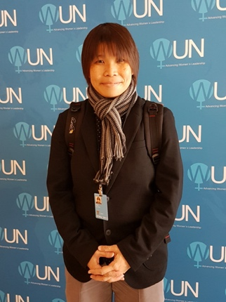 |  | Creating a Mentally Friendly &  Healthy Learning Environment  by Ms Porsche Poh  23rd APRIL 2024 l 9.00am to 4.00pm  St Joseph’s Institution (ISH Training Room)
Closing Date:  9th April 2024,  or when all seats are taken up. | Only 40 seats available.  ASCD (Singapore) Members will get priority if forms are received by  2nd April 2024.  Registration closes as soon as seats are all taken up.
Workshop Fees | ASCD (S) Members: S$265.00 | Non-Members: S$315.00  (Inclusive of morning break and lunch)

Become an ASCD (Singapore) Member!
Individuals who pay the Non-Member Fees will receive Ordinary Membership.
Schools can pay for Institutional Membership: S$300.00 to send teachers at Member Rate.
All Memberships will be valid until 31st December 2024

Please request for Membership Form at ascdadmin@work-solutions.com

Register here for Individual, Self-Paying Participants (For schools, use next page)
 | Name of Participant | Email Address | Teaching Levels | Teaching Subject | Mobile Phone No. | ASCD Singapore Membership Type (Please click one)
1 |  |  |  |  |  | ☐ Life  ☐ Ordinary  ☐ Non-Member
 | Postal Address (include postcode)
2 |  |  |  |  |  | ☐ Life  ☐ Ordinary  ☐ Non-Member
 | Postal Address (include postcode)

Important Note:

Please complete the Confirmation of Payment Section on the next page.

Register for Schools, Organisations and Institutional Members on next page please >>>

Register here for Schools/Organisations ASCD (Singapore) Institutional Members & Non-Member Schools)
Name of School or Organisation
Postal Address |  |  |  |  |  | Postcode
Name of Liaison Person |  |  |  |  |  | Office  Phone No.
Designation of Liaison Person |  |  |  |  |  | Extension No.
Liaison Person’s Email Address |  |  |  |  |  | Mobile Phone No.
Particulars of Participants from Schools
Note: Please complete the Confirmation of Payment Section
No | Name of Participant |  | Email Address | Teaching Levels | Teaching Subjects |  | Mobile Phone No. |  | ASCD Singapore Membership Type (Please check one)
1 |  |  |  |  |  |  |  |  | ☐ Life / Ordinary  ☐ Institutional  ☐ Non-Member
2 |  |  |  |  |  |  |  |  | ☐ Life / Ordinary  ☐ Institutional  ☐ Non-Member
3 |  |  |  |  |  |  |  |  | ☐ Life / Ordinary  ☐ Institutional  ☐ Non-Member
4 |  |  |  |  |  |  |  |  | ☐ Life / Ordinary  ☐ Institutional  ☐ Non-Member
5 |  |  |  |  |  |  |  |  | ☐ Life / Ordinary  ☐ Institutional  ☐ Non-Member
6 |  |  |  |  |  |  |  |  | ☐ Life / Ordinary  ☐ Institutional  ☐ Non-Member

Insert more rows if required.

Confirmation of Payment (Please select one option with “X”)

☐ | 1 | Please e-invoice my school (the following information MUST be provided)  SBU No.:  Attention to:
☐ | 2 | Please issue a hard-copy invoice and send via email. Payment will be made immediately on receipt of invoice. (Only for institutes, schools)
☐ | 3 | Cash or Online Bank Transfers can be made to our bank account:  Payee: ASCD (Singapore)  Bank Account No.: DBS Bank A/c Number: 020-004574-4  UEN No.: S89SS0105L001  Please email your transaction advice to ascdadmin@work-solutions.com
☐ | 4 | Cheques should be made payable to ASCD (SINGAPORE)  Cheque No: _____________Amount of Cheque: S$ ______________ is attached.  Please post original forms and payment to the address listed below.  ASCD (S) Secretariat, 73 Ubi Road 1, #07-62 Oxley BizHub, Singapore 408733

